**Project Design Phase-II Data Flow Diagram & User Stories**

|  |  |
| --- | --- |
| Team ID | PNT2022TMID14015 |
| Project Name | Emerging Methods for Early Detection of Forest Fires |
| Maximum Marks | 4 Marks |

**Data Flow Diagrams:**

# COLLECT DATA 2. EVALUATE DATA SET 3. IMPLEMENT ALGORITHMS 4. EVALUATE THE ACCURACY OF EACH ALGORITHMS 5. DISPLAY RESULTS

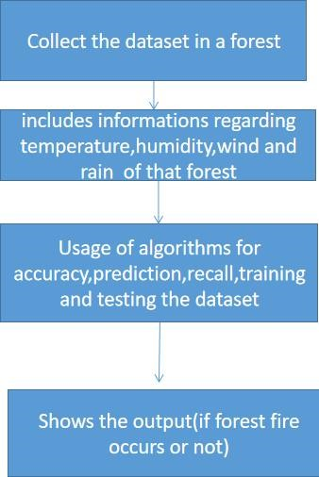

DFD

Level

0

(

Industry

Standard)

**User Stories**

Use the below template to list all the user stories for the product.

|  |  |  |  |  |  |  |
| --- | --- | --- | --- | --- | --- | --- |
| **User Type** | **Functional**  **Requirement (Epic)** | **User Story Number** | **User Story / Task** | **Acceptance criteria** | **Priority** | **Release** |
| Environmentalist | Collect the data | USN-1 | As an Environmentalist,it is necessary to collect the data of the forest which includes temperature,humidity,wind and rain of the forest | It is necessary to collect the right data else the prediction may become wrong | High | Sprint-1 |
|  |  | USN-2 | Identify algorithms that can be used for prediction | To collect the algorithm to identify the accuracy level of each algorithms | Medium | Sprint-2 |
|  |  | USN-3 | Identify the accuracy of each algorithms | Accuracy of each algorithm-calculated so that it is easy to obtain the most accurate output | High | Sprint-2 |
|  |  | USN-4 | Evaluate the Dataset | Data is evaluated before processing | Medium | Sprint-1 |
|  |  | USN-5 | Identify accuracy,precision,recall of each algorithms | These values are important for obtaining the  right output | High | Sprint-3 |
|  |  | USN-6 | Outputs from each algorithm are obtained | It is highly used to predict the effect and to take precautionary measures. | High | Sprint-4 |